We employed the scientific programming language Matlab (e.g., Sharma and Martin, 2009) to develop a user-friendly graphical user interface (GUI) software. The software's GUI is organized into six panels (see Fig. 1) with the following specifications.

**(1) Gravity parameters panel**: Users can select the type of gravitational parameters to be computed, namely the gravitational potential (P), gravitational attraction (), and vertical gravitational gradient (). In the following text, we will use the symbol Gz to denote, and Gzz to denote .

**(2) Calculation methods panel:** Two methods are offered to users. The first method divides the volumetric mass density into multiple layers with variable upper and lower bounds, while method two divides it into multiple concentric circles with constant upper and lower bounds.

**(3) Computation area panel:** Users have two options to choose, either regular grid or irregular point positions. For the regular grid option, users need to input the latitude and longitude range. Specifically, for the latitudinal and longitudinal range, the maximum, minimum, and interval values must be provided. In the case of irregular points, users upload a data file containing the coordinates of computation points.

**(4) Input parameters panel:** Three key parameters have to be selected. The first parameter defines the maximum degree/order of the spherical harmonic expansion, the second parameter defines the computational height, and the third parameter defines the number of radial layers dividing the volumetric mass density.

**(5) Results panel:** Once all the necessary parameters and input files are provided, the computation results are displayed in the panel, showing both the tables and statistics of results.

**(6) Visualization panel:** This panel displays computation results.

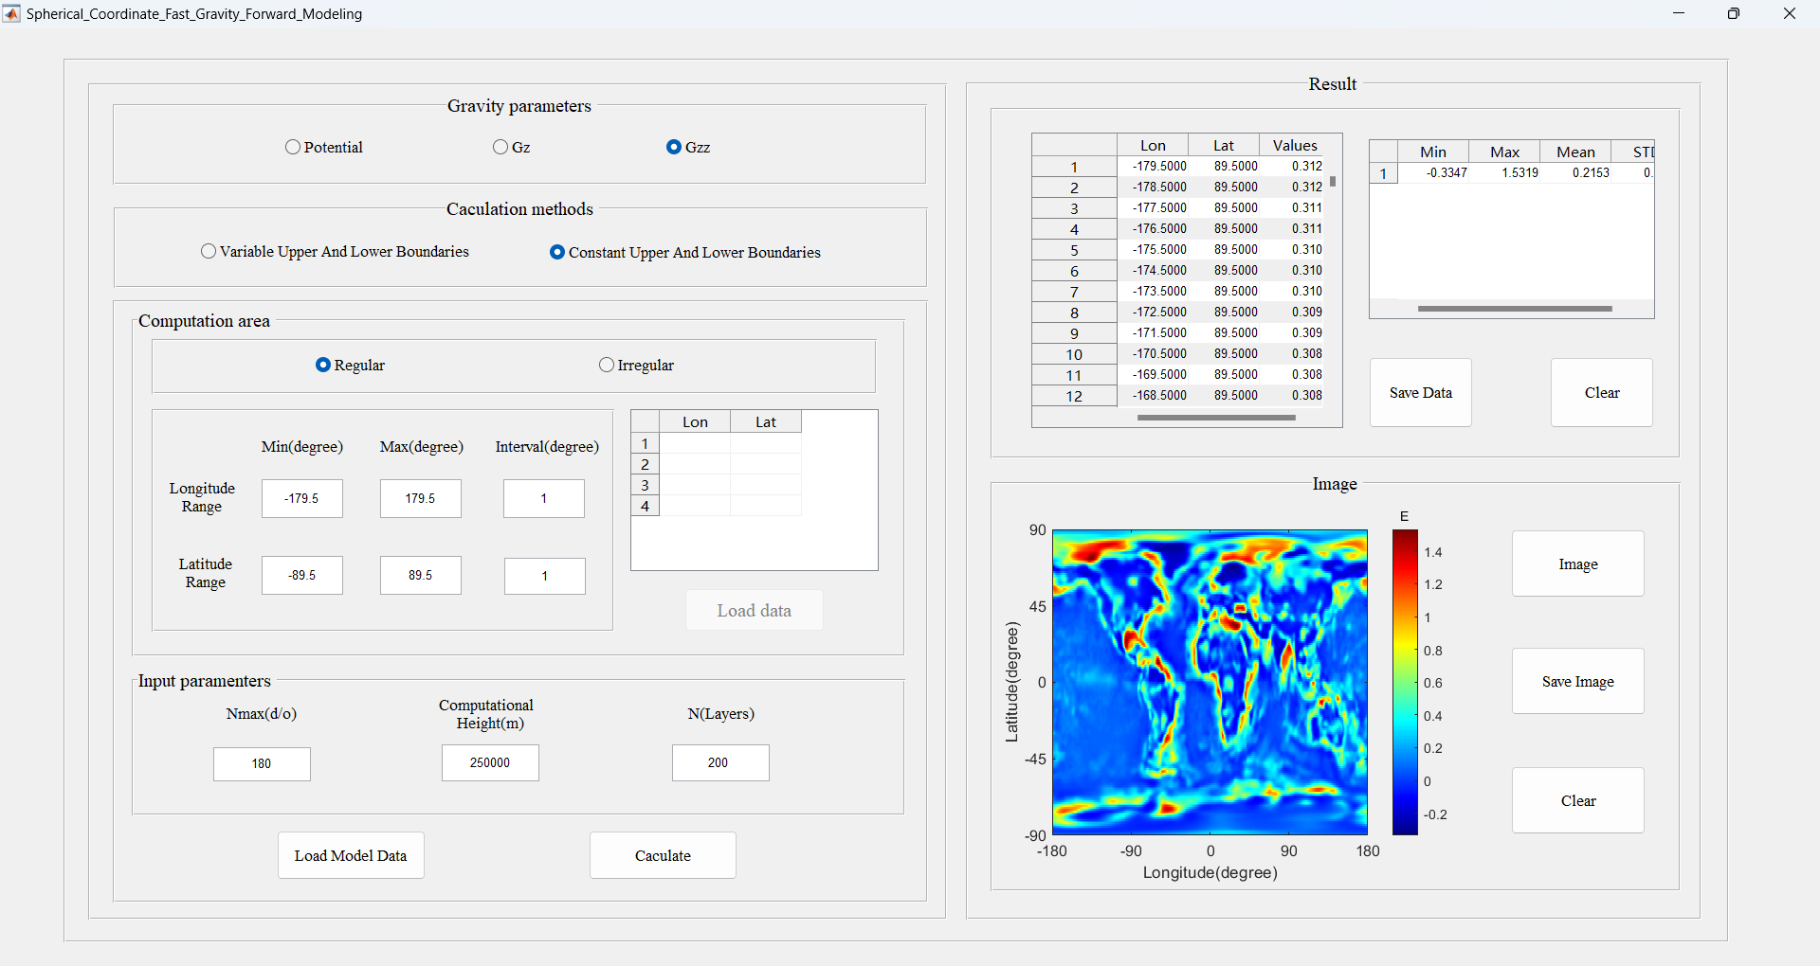

**Fig. 1** Main GUI of the developed software

Fig. 2 shows the sub-GUI for the model data. When we click the 'Load Model Data' button on the main GUI, the sub-GUI for the model data will appear. The test model data is organized into separate files for bounds and densities. It consists of two panels.

**(1) Boundary panel:** The model data consists of four columns: longitude, latitude, upper bound, and lower bound. If the model includes multiple layers, the data can extend across additional columns.

**(2) Density panel:** Here, the density values are organized to correspond with the individual layers.

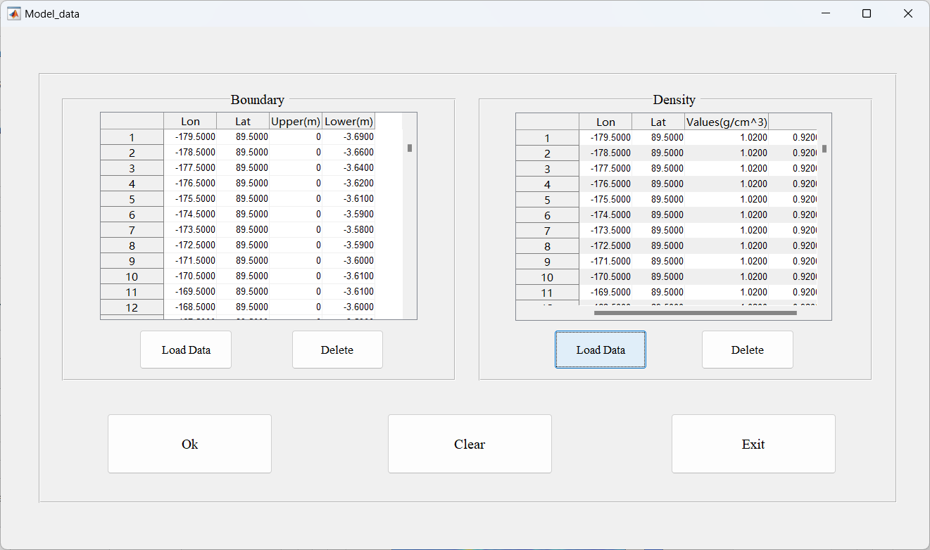

**Fig. 2** Sub-GUI of the model data